**ORgSys**

**(Organization Recognition System)**

Analysis Classes

Class Diagram

Submitted to:

Asst. Prof. Ma. Rowena C. Solamo

Faculty Member

Department of Computer Science

College of Engineering

University of the Philippines, Diliman

Submitted by:

GRANADA, Patrick James B.

MERCADO, Emir R.

YAP, Sharmaine A.

In partial fulfillment of Academic Requirements

Revision Control

*History Revision:*

| Revision Date | Person Responsible | Version  Number | Modification |
| --- | --- | --- | --- |
| 10/15/2013 | Emir Mercado  Sharmaine Yap  Patrick Granada | 1.0 | Initial Document |
| 10/16/2013 | Emir Mercado | 2.0 | Added operations to entity classes  Attached links to Document entity class |

*System Name*: ORgSys (Organization Recognition System)

*Description*: The system's purpose is primarily to provide the Office of Student Affairs of UP Diliman's College of Engineering a means of evaluating the organizations during their application period for recognition for the whole school year. This system provides a way for the unit heads to upload the documents submitted by the organizations online. It will also serve as a venue for Associate Dean for Student Affairs and the Review Committee to provide the organizations with the list of required documents requirements for approval and to check if the member roster of the organization is valid.

*Class Diagram*:

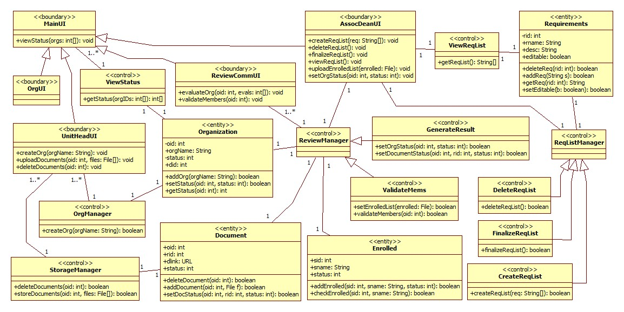

*Boundary Classes:*

|  |  |  |
| --- | --- | --- |
| **MainUI** | Main template of user interfaces | |
| Behavior List | **viewStatus** | **viewStatus** displays the recognition status of the orgs  Input: **int[] orgs** - list of orgs IDs of orgs to view  Output: **void** - the status of the orgs requested will be displayed |

|  |  |  |
| --- | --- | --- |
| **AssocDeanUI** | (extends ***MainUI*** class) This is the boundary class for the Associate Dean for Student Affairs. | |
| Behavior List | createReqList | **createReqList** creates an initial draft of a requirements checklist  Input: **String[] req** - list of requirements  Output: **void** |
| deleteReqList | **deleteReqList** deletes the entire list of requirements.  Input: **none**  Output: **void** |
| finalizeReqList | **finalizeReqList** makes the created draft of requirements checklist uneditable.  Input: **none**  Output: **void** |
| viewReqList | **viewReqList** displays the current requirements checklist, finalized or not  Input: **none**  Output: **void** |
| uploadEnrolledList | **uploadEnrolledList** uploads the list of enrolled students needed by the system to verify the validity of the organizations' members  Input: **File enrolled** - file that contains the list of enrolled students in the college/university, depending on what the associate dean is able to retrieve from the university registrar.  Output: **void** |
| setOrgStatus | **setOrgStatus** sets the overall status of the organization with respect to the evaluation of the Associate Dean for Student Affairs  Input: **int oid, int status** - the organization's ID in the database and the status to be assigned to that organization  Output: **void** |

|  |  |  |
| --- | --- | --- |
| **UnitHeadUI** | (extends ***MainUI*** class) This is the boundary class for the unit heads. | |
| Behavior List | createOrg | **createOrg** creates an account for the organizations to participate in the renewal process of the college  Input: **String orgName**  Output: **void** |
| uploadDocuments | **uploadDocuments** uploads the organization's documents in the online storage system  Input: **int oid, File[] files** - the organization's ID in the database and the files of their documents to be uploaded  Output: **void** |
| deleteDocuments | **deleteDocuments** deletes all the documents owned by the organization in the online storage system  Input: **int oid** - organization's ID in the database  Output: **void** |

|  |  |  |
| --- | --- | --- |
| **ReviewCommUI** | (extends ***MainUI*** class) this is the boundary class for the review committee | |
| Behavior List | evaluateOrg | **evaluateOrg** enables the user to give their evaluations to all the documents submitted by the organizations.  Input: **int oid, int[] evals** - the organization's ID in the database and the evaluations to be given by the review committee per document  Output: **void** |
|  | validateMembers | **validateMembers** checks the online storage for the file that contains the members of the organization and  Input: **int oid** -the organization's ID  Output: **void** |

|  |  |  |
| --- | --- | --- |
| **OrgUI** | (extends ***MainUI*** class) this is the boundary class for the organizations | |
| Behavior List | none |  |

*Control Classes:*

|  |  |  |
| --- | --- | --- |
| **ViewStatus** | Control class for viewing the recognition status of organization/s | |
| Behavior List | getStatus | Write the description of the behavior.  Input: **int[] orgIDs** - array of orgIDs in the database  Output: **int[]** - array of statuses of the organizations requested |

|  |  |  |
| --- | --- | --- |
| **StorageManager** | Control class for managing the online storage system | |
| Behavior List | deleteDocuments | **deleteDocument** deletes all of the organization's files in the online storage and in the database  Input: **int oid** - the organization's ID in the database  Output: **boolean** - true if the files are successfully deleted |
| storeDocuments | **storeDocuments** stores the files uploaded by the unit head into the online storage sytem  Input: **int oid, File[] files** - the organization's ID in the database and the files to be stored in the online storage system  Output: **boolean** - true if the the documents are successfully stored |

|  |  |  |
| --- | --- | --- |
| **OrgManager** | Control class for managing the organizations applying for recognition | |
| Behavior List | createOrg | Write the description of the behavior.  Input: **String orgName** - the name of the org that will be given an account by the system  Output: **boolean** - true if the account is successfully created |

|  |  |  |
| --- | --- | --- |
| **ReviewManager** | Control class for managing the org reviewing feature of the system | |
| Behavior List | none |  |

|  |  |  |
| --- | --- | --- |
| **ValidateMems** | (extends ***ReviewManager****)* Control class for validating the list of members submitted by each organizations | |
| Behavior List | setEnrolledList | **setEnrolledList** extracts the information from the file retrieved from the university registrar to be used for validating the members of the organizations  Input: **File enrolled** - the file containing the list of enrolled students  Output: **boolean** - true if the file is processed successfully |
| validateMembers | **validateMembers** checks whether all members of the organization are currently enrolled.  Input: **int oid, File memList** - the organization's ID in the database, and the file containing the members of the organization  Output: **boolean** - true if all members in the member list is a currently enrolled student of the university |

|  |  |  |
| --- | --- | --- |
| **GenerateResult** | (extends ***ReviewManager***) Control class for evaluating the documents and overall recognition status of the organization | |
| Behavior List | setOrgStatus | Write the description of the behavior.  Input: **int oid, int status** - the organization's ID in the database and the status to be given to the organization  Output: **boolean** - true if the status is set successfully |
| setDocumentStatus | Write the description of the behavior.  Input: **int oid, int rid, int status** - the organization's ID in the database, the requirement's ID in the database, and the evaluation to be given to the document submitted by the organization  Output: **boolean** - true if the status is set successfully |

|  |  |  |
| --- | --- | --- |
| **ReqListManager** | Control class for managing the requirements checklist | |
| Behavior List | none |  |

|  |  |  |
| --- | --- | --- |
| **CreateReqList** | (extends ***ReqListManager***) Control class for creating a requirements checklist | |
| Behavior List | createReqList | **createReqList** creates an instance of a requirements checklist  Input: **String[] req** - the list of requirements in text form  Output: **boolean** - true if the checklist is created successfully |

|  |  |  |
| --- | --- | --- |
| **DeleteReqList** | (extends ***DeleteReqList***) Control class for deleting a requirements checklist | |
| Behavior List | deleteReqList | **deleteReqList** deletes the currently saved requirements checklist in the system  Input: **none**  Output: **boolean** - true if the checklist is deleted succesfully |

|  |  |  |
| --- | --- | --- |
| **FinalizeReqList** | (extends ***DeleteReqList***) Control class for finalizing a requirements checklist | |
| Behavior List | finalizeReqList | **finalizeReqList** finalizes the existing requirements checklist and makes it uneditable  Input: **none**  Output: **boolean** - true if the checklist is finalized successfully |

|  |  |  |
| --- | --- | --- |
| **ViewReqList** | Control class for viewing the requirements checklist | |
| Behavior List | getReqList | **getReqList** gets the list of requirements from the database to be  Input: **none**  Output: **String[]** - the list of requirements |

*Entity Classes:*

|  |  |  |
| --- | --- | --- |
| **Organization** | Entity class for the list of organizations | |
| Attribute List | oid | (**int**)organization ID assigned by the database |
| orgName | (**String**) name of the organization |
| did | (**int**) department ID or number where the organization is housed |
| status | (**int**) overall status of the organization |
| Behavior List | addOrg | **addOrg** adds an organization into the Organization database  Input: **String orgName**  Output: **boolean** |
| setStatus | **setStatus** modifies the status of an organization in the database  Input: **int oid, int status**  Output: **boolean** |
| getStatus | **getStatus** retrieves the status value of the organization in the database  Input: **int oid**  Output: **int** |

|  |  |  |
| --- | --- | --- |
| **Requirements** | Entity class for the requirements checklist | |
| Attribute List | rid | (**int**) requirement ID assigned by the database |
| rname | (**String**) name of the requirement |
| desc | (**String**) details of the requirement |
| Behavior List | deleteReq | **deleteReq** deletes a requirement entry in the database  Input: **int rid**  Output: **boolean** |
| addReq | **addReq** adds a requirement in the database  Input: **String s**  Output: **boolean** |
| getReq | **getReq** retrieves a requirement from the database  Input: **int rid**  Output: **String** |
| setEditable | **setEditable** allows/forbids editing of the Requirements database  Input: **boolean b**  Output: **boolean** |

|  |  |  |
| --- | --- | --- |
| **Document** | Entity class for the list of documents submitted by the organizations | |
| Attribute List | oid | (**int**) organization ID assigned by the database |
| rid | (**int**) requirement ID assigned by the database |
| dlink | (**URL**) download link of the document |
| status | (**int**) evaluation status of the document |
| Behavior List | deleteDocument | **deleteDocument** deletes a document in the database  Input: **int oid**  Output: **boolean** |
| addDocument | **addDocument** adds a document entry in the database  Input: **int oid, File f**  Output: **boolean** |
| setDocStatus | **setDocStatus** modifies the status value of a document in the database  Input: **int oid, int rid, int status**  Output: **boolean** |

|  |  |  |
| --- | --- | --- |
| **Enrolled** | Entity class for the list of enrolled students | |
| Attribute List | sid | (**int**) student's official ID number |
| sname | (**String**) name of student |
| status | (**int**) enrollment status of the student |
| Behavior List | addEnrolled | **addEnrolled** adds an enrolled student in the database  Input: **int sid, String sname, int boolean**  Output: **boolean** |
| checkEnrolled | **checkEnrolled** checks the status of a student in the database  Input: **int sid, String sname**  Output: **boolean** |